Independent Panel Report on a Provider’s Programme Review

Provider | Dublin Business School (“DBS”)
Programme(s) Reviewed | Principal Programme  Master of Science in Applied Psychology: NFQ Level 9, 90 ECTS  Embedded Programme  Postgraduate Diploma in Science in Applied Psychology (EXIT AWARD): NFQ Level 9, 60 ECTS

Independent Panel Members
Name | Role on Panel | Affiliation
Dr Josephine Browne | Chair | Former Head of Faculty of Enterprise and Humanities, IADT
Matthew Hurley | Report Writer | Independent Consultant
Dr Audrey Dunn Galvin | Academic Representative | Programme Director, University College Cork
Dr Steve Loughnan | Academic Representative | Professor, University of Edinburgh
Dr Brid Davis | Industry Representative | Clinical Psychologist in Primary Care, Health Service Executive (HSE)
Aoife Fahy | Learner Representative | Currently undertaking a BSc in Psychology and Disruptive Technology

All members of the independent Panel declared their independence of Dublin Business School and that they have no conflict of interest.

Introduction
In accordance with statutory requirements and DBS’ own internal review schedule, programmes validated by QQI are required to undergo a process of revalidation after a set period of time (typically five years) to ensure they remain current, relevant and fit for purpose. This report details the evaluation of an independent Panel convened for the purpose of evaluating DBS’ Master of Science in Applied Psychology and its embedded exit award of the Postgraduate Diploma in Science in Applied Psychology and making a recommendation to QQI as to whether it should be revalidated.

Evaluation Process

Documents Supplied to the Panel
 | Document Type | Document Name
 | Agenda | Agenda_Programme Review_MSc Applied Psychology
 | Appendices | Class Recording Strategy for Master of Science in Applied Psychology 2026
 | Appendices | Education and Training needs Met by the Master of Science in Applied Psychology 2026
 | Appendices | Master of Science in Applied Psychology Indicative Timetables
 | Appendices | Module and Assessment Document_Master of Science in Applied Psychology 2026
 | Appendices | Programme Handbook Master of Science in Applied Psychology 2026
 | Appendices | Programme Origins and Development of Master of Science in Applied Psychology 2026_27
 | Appendices | Programme Team CVs_Master of Science in Applied Psychology 2026
 | Appendices | Stakeholder Involvement in Programme Development MSc in Applied Psychology 2026
 | Descriptor | Master of Science in Applied Psychology_Programme Document_2026
 | Report | Master of Science in Applied Psychology 2026_Programme Review Report_2026
 | Supporting Documents | 2021 Documents
 | Supporting Documents | Annual Programme Reports
 | Supporting Documents | Attendance Data
 | Supporting Documents | Certificate of Validation
 | Supporting Documents | Exam-CA Samples
 | Supporting Documents | External Examiner Reports
 | Supporting Documents | HEA Graduate Tends_Psychology Taught Masters
 | Supporting Documents | Progression, Demographics, and Results Data
 | Supporting Documents | QQI Criteria and Handbook
 | Regulatory Documents | Cover Letter Declaration_MSc Applied Psychology
 | Regulatory Documents | Deed of Guarantee
 | Regulatory Documents | Fee Cover Note MSc Applied Psychology
 | Regulatory Documents | PEL Refund Arrangements MSc Applied Psychology
 | Terms of Reference | MSc Applied Psychology & Exit Award ToRV3

Provider’s Representatives Met
 | Person | Role / Job Title
 | Darragh Breathnach | Chief Operating Officer & Registrar
 | Richard Barry | Chief Academic & Innovation Officer
 | Dr. Rosie Reid | Academic Director
 | Dr. Pauline Hyland | Assistant Academic Director
 | Anita Dwyer | Assistant Registrar
 | Amy Hayes | Portfolio Performance Manager
 | Dr. Keith O’Donnell | Programme Level Manager
 | Shane Mooney | Head of Student Experience
 | Nicholas Kelly | Head of Faculty Management
 | Janine Jackson | Faculty Manager
 | Sarah Sharkey | Senior Learner Support and Retention Officer
 | Tanya Balfe | Admissions Manager
 | Trevor Haugh | Head of Academic information and Resource Centre/Library
 | Francisca Knight | Head of Academic Operations
 | - Dr. Michael Collins  - Dr. John Hyland  - Serena Bryans  - Paul Halligan  - Clare King  - Ray McKiernan  - Cassandra Murphy  - Michael Nolan  - Dr. Mary Peyton  - Dr. Sean Smith | Lecturing Team
 | - Student Representatives Met | -

Description of evaluation process
Following receipt of the programme documentation, members of the independent Panel conducted an individual desk review and prepared initial observations before convening for a private meeting the morning of the virtual site visit. At this private meeting, the Panel identified areas of strength in the application as well as areas requiring further inquiry and further enhancement.
The virtual site visit was held online via Zoom and allowed the Panel to meet with staff across governance, management, operation, programme delivery and administration roles. These discussions were engaging and honest, and afforded the Panel insight beyond what could be gleaned from the documentation alone.
The programmes have experienced a number of substantive changes, informed by extensive internal and external stakeholder consultation, and the Panel was overall pleased with the programmatic review conducted and the modifications proposed to the revised programme. Notwithstanding this, the Panel identified a number of areas for review and consideration, ultimately agreeing on a recommendation that the programme is satisfactory subject to proposed special conditions.

Panel Findings on Provider Programme Review Report
The following is the Panel’s commentary and recommendations on the provider’s programme review report. It follows the section structure of the report in headings and in sequence. References to specific parts of the provider report will use the relevant report reference e.g. 2.2.4 Programme Management

- Context and Terms of Reference for the Programme Review
Commentary:
An independent Panel has been convened to conduct an evaluation of DBS’ MSc in Applied Psychology and its embedded exit award of the Postgraduate Diploma in Applied Psychology. As part of this evaluation, the Panel reviews the performance of the programmes over the last validation period and DBS’ own programmatic review in respect of this. Accordingly, DBS’ Programme Review Report, the product of its internal review, is a key source of quantitative and qualitative data.
Appropriate terms of reference have been prepared which outline the purpose of the programme review and revalidation processes and the key modifications proposed for the revised programmes.
Recommendations:
The Panel is satisfied with the context and terms of reference for the programme review and has no specific recommendations to make.
__________________________________________________________________________________
- Provider Information and Programme Context
Commentary:
DBS is a Dublin-based provider of higher education and training established in 1957. With a scope of provision spanning NFQ Levels 6 to 9, DBS delivers programmes across a range of disciplines, including accounting, business, film and creative media, finance, humanities and social sciences, law, marketing, and the computer sciences.
The Master of Science in Applied Psychology is positioned within the Psychology and Social Sciences Discipline and includes an embedded exit award of the Postgraduate Diploma in Science in Applied Psychology for learners who are unable to complete the research component of the full Master’s.
Recommendations:
The Panel is satisfied with the provider information and programme context and has no specific recommendations to make.
- Baseline qualitative and quantitative information

Programme Data Overview
Commentary:
The programme has seen a steady rise in applications over the last validation period, with 90 applications being received for the full-time version in 2021/22, 139 in 2022/23, 153 and in 2023/24, and 228 in 2024/25. The part-time version fluctuated somewhat during the same period but rose nonetheless from 18 to 23 (albeit with a high of 27 in 2022/23). The Programme Review Report relates the overall increase in applications to a growing interest and demand in such programmes and a societal focus on mental health and well-being (additionally contributing to the programme’s curricular shift toward mental health and well-being).
With the increasing number of applications, enrolments figures have also risen. For example, there were 14 enrolments on the full-time version in 2021/22 which rose to 26 in the 2024/25 intake. Part-time learners increased also, though by a marginal amount (11 in 2021/22 to 13 in 2024/25, with a high of 14 in 2022/23). However, while the actual number of enrolments in a given year increased, the conversion rate decreased. This sat at 23% in 20221/22 and dropped to 16% in 2024/25. The Programme Review Report acknowledges this decrease but also notes that the programme continues to attract substantial interest.
The gender breakdown of learner cohorts has typically been weighted more towards female learners, although the 2024/25 year saw an almost even split (48.65% male, 51.35% female). Learners from Ireland have been in the majority each year over the last validation period, though there has been a notable increase in the number of learners from Asia (29.73% in 2024/25). Age demographics are primarily in the 23-30 and 31-40 brackets, although there have been a number of learners each year below 23 and between 41 and 50.
Attrition, transfer and progression data are systematically captured, with DBS noting that the global pass rate for the programme based on the total number of enrolled learners in 85.56%. A drop in the pass rate to 77% in the 2024/25 academic year is acknowledge in the Programme Review Report, which DBS commenting that learners may be experiencing certain challenges with the programmes. A sharp drop in pass and deferral rates on the part-time programme was also recorded in 2024/25, with 62% of learners passing their exams and 31% deferral.
Surveys conducted in relation to graduate destinations have highlighted how many graduates are successfully progressing to employment; however, DBS recognises a need to enhance this and has developed specific steps to achieve this.
Recommendations:
The Panel has no specific recommendations to make.

Programme Delivery and Teaching & Learning Strategies

Commentary:
DBS’ learning environment includes access to a range of modern facilities, equipment and resources, including learning spaces, audio-visual equipment, library access, a virtual learning environment, computer labs, and technology for recording classes. A dedicated Psychology Laboratory is in place to facilitate experimental research and affords access to biometric data collection, including EEG and EDR as well as stimulus presentation computers and audio equipment.
Learner workload is closely monitored and burden mitigated through a combination of strategies, including the completion of summative assessment worksheets during class time, the scheduling of assessments outside the teaching term, and the inclusion of formal exams.
The majority of modules with classroom-based learning and live online synchronous learning utilise a teacher-to-learner ration of 1:50, with the exception of the live online synchronous delivery of the Advanced Quantitative Research Methods and Analysis module and the Capstone modules, each of which employ 1:25 ratio. Mentoring and small group tutoring otherwise utilises a 1:35 ratio.
Teaching and learning was designed to be learner-centred and multi-modal using a mix of on-site and online delivery methods. The role of digital technologies was considered an important factor in creating rich learning experiences and increasing flexibility. Assessment utilised a wide range of assessment types, including: formal exams, individual essays, reports, group projects, reflections and the dissertation. The Programme Review Report recognises the need to revise certain aspects of the teaching, learning and assessment strategies in order to ensure these are sufficiently robust and future-proofed. This has involved embedding digital media into assessment, the enhanced use of UDL principles, the incorporating of career-oriented content, and increasing flexibility for part-time learners.
Recommendations:
The Panel has no specific recommendations to make.

- Evaluation of the programme by stakeholders

Evaluation by current learners and graduates of the programme
Commentary:
DBS gathers feedback from learners on a systematic basis and there are established processes to ensure this feedback is meaningfully considered and informs future programme reviews and amendments. A formal Class Representative system also provides a pathway for learners to have their feedback heard. Details of class rep meetings from the last validation period are provided in the Programme Review Report. Issues were highlighted in relation to the multi-modal delivery model and assessment workload, which have been the focus of several amendments in the revised programme.
Recommendations:
The Panel has no specific recommendations to make.

Evaluation of the programme by Staff
Commentary:
Feedback is gathered from staff on an ongoing basis through Programme Teams meetings and Programme Boards. Feedback relating to the MSc in Applied Psychology has led to proposed modifications across a range of categories, including: an increase in resources supporting the development of academic skills; the revision of several learning outcomes to reflect the shift in the programme’s focus toward mental and well-being; an update to the programme’s curriculum for currency; an increase in the amount of career-oriented content; the enhancement of the programme’s assessment strategy to ensure it is sufficiently robust in an age of widespread AI use; the introduction of a new delivery mode; and the removal of the elective two-pathway model for the Capstone modules.
Recommendations:
The Panel has no specific recommendations to make.

External Examiner Feedback
Commentary:
External Examiners reports from the last validation period have been very positive, with praise given to the diversity and fairness of assessments, as well as the quality of teaching and learner support. DBS has taken on board recommendations arising from these reports and identified how it can strengthen its practice accordingly, such as by developing clearer and more informative assessment briefs and rubrics, and enhancing the clarity of communications between DBS and the External Examiner.
Recommendations:
The Panel has no specific recommendations to make.

- Programme Quality Assurance

Complaints, appeals and commendations
Commentary:
No formal complaints were logged over the last validation period, while seven formal appeals were logged, of which one was upheld. Procedures are in place at an institution level to facilitate complaints and appeals and DBS is satisfied that these are effective. Indeed, it is noted that expressions of dissatisfaction are typically resolved at an informal level before being escalated, which appears to be the case here.
Recommendations:
The Panel has no specific recommendations to make.

Quality Assurance Systems and Processes
Commentary:
DBS has in place QQI-approved quality assurance procedures underpinning its provision which are subject to ongoing monitoring and review. DBS is additionally cognisant of its obligations in relation to professional, statutory and regulatory bodies (PSRBs), particularly CORU and the Psychology Society of Ireland (PSI), although it is noted that “there are no current regulations regarding PSI accreditation for postgraduate Applied Psychology programmes” (Programme Review Report, p.119)
Recommendations:
The Panel has no recommendations to make.

Additional Quality Assurance Systems and Processes required (e.g. online delivery / assessment)
Commentary:
The Programme Review Report recognises the need for DBS to ensure the ongoing monitoring and enhancement of its quality assurance procedures to support the new fully online version of the programme. However, this does not constitute a new or additional quality assurance system, as relevant procedures are already in place.
Recommendations:
The Panel has no specific recommendations to make.

- Summary Analysis of the programme
Commentary:
The Programme Review Report presents a comprehensive analysis of the programme’s strengths, weaknesses, opportunities and threats (SWOT). The Programme Team identified the advanced research skills taught to learners as a particular strength given their applicability to a range of professional pathways. The high completion and pass rates are acknowledged, as is the historic diversity of learners, and the positive graduate employment opportunities.
In terms of weaknesses, establishing and maintaining consistent expertise in organisational psychology to support the inclusion of such modules is acknowledged as a challenge, and the programme’s harnessing of digital technology skills in assessment is seen as limited. The risk associated with generative AI use in assessment was noted, though it is hoped this will be somewhat mitigated through the proposed assessment modifications in the revised programme.
That part-time learners may find a fully online programme more viable than one which is fully on site was identified as a threat; though DBS is aiming to address this through its revised modality offerings (i.e. full-time on site; part-time on site; part-time fully online). Finally, the potential of the new modality offerings and, in particular, the provision of a part-time version of the programme, were seen as particular opportunities.
Recommendations:
The Panel is satisfied that the SWOT analysis was meaningfully conducted and acknowledges many of the areas which DBS has ultimately modified in the revised programme.

- Revision of the programme
Commentary:
The following modifications are proposed for the revised programme:
- The minimum intended programme learning outcomes have been revised to reflect the increased focused on mental health and wellbeing and the discontinuation of a Capstone elective option.
- An additional part-time day programme, which can be taken over two academic years, is to be introduced. This will have one September intake, which is intended to replace the January intake for the current part-time night programme.
- Three new modules have been added, each worth 5 ECTS credits:
  - Psychological and Behavioural Interventions
  - Clinical and Neuropsychological Presentations
  - Personal Development and Stress Management
  - Scientific Psychology
- Four modules have been removed:
  - Psychometrics and Psychometric Training
  - Applied Neuroscience
  - Motivation Leadership and Positive Psychology
  - Capstone 1 (Research Placement) (Elective)
- Two changes are proposed to module titles and structure:
  - Professional Issues and Ethics in Applied Psychology, previously worth 10 ECTS credits, is to be divided into modules of 5 ECTS credits each: Professional Issues and Ethics in Applied Psychology 1 and Professional Issues and Ethics in Applied Psychology 2.
  - Capstone 2 is to be renamed to Capstone.
  - Life Transitions and Interventions has been reduced from 10 ECTS credits to 5 ECTS credits.
- Several changes are proposed to module content and module learning outcomes.
- Several changes are proposed to the teaching and learning strategy, including a transition from multimodal delivery so that the full-time programme will be delivered fully on site, face to face, while the part-time evening programme will be delivered fully online. The new part-time day programme is to be delivered via a blended modality.
- Several changes are proposed to the assessment strategy, including more digital technology-based assessment and generative AI-robust assessment.
- Quality assurance procedures have been enhanced in view of the pivot toward blended delivery for the part-time evening programme.
Recommendations:
The Panel is overall satisfied that the proposed revisions are appropriate and accepts the rationale put forward in respect of these. Notwithstanding this, some conditions of validation and recommendations have been identified which may impact the organisation, management, structure and/or content of the revised programme.

Overall Findings

- Commentary on review process:
The Panel is satisfied that the review of the MSc in Applied Psychology and its embedded exit award, the PGDip, conducted by DBS is thorough and informed by range of internal and external stakeholder feedback, as well as relevant quantitative and qualitative data. The results of this review are systematically and comprehensively documented and supported, as appropriate, by appendices. The comprehensive nature of the review provides a clear evidence trail for the modifications to the revised programme.
- Recommendations on review process:
The Panel has no recommendations to make regarding the review process for the MSc in Applied Psychology. However, there are a number of conditions and recommendations identified and contextualised in the Independent Evaluation Report which may have implications on future reviews.
- Commentary on programme revisions:
The Panel is overall satisfied that the revisions to the programme have a sound basis and rationale and will serve to strengthen the programme as it is delivered over the next validation period. In particular, the Panel welcomes the continued use of diversified assessment types and the enhancements made on the basis of feedback to reduce assessment workload, change the multimodal delivery model, and embed greater career-oriented content.
- Recommendations on programme revisions:
In its evaluation of the programme as a whole, which comprises a review of the programme as it performed over the last validation period and an evaluation of the revised programme, the Panel identified a number of special conditions of validation and recommendations. These are further contextualised in the Independent Evaluation Report.

Special Conditions of Validation
1. DBS must revisit the title of the programme to determine whether it is truly fit for the purpose of informing prospective learners and employers or whether an alternate title may be more appropriate for conveying the primary focus of the programme, e.g. “MSc in Applied Psychology (Health and Wellbeing)”.
  - Where the title is ultimately considered appropriate, a strong, written rationale must be presented for this.

2. Given the notably lower outcomes of the capstone module compared with other modules, DBS must progress the integration of its framework to assist learner progression through the dissertation.

Recommendations
- The Panel recommends that DBS more clearly articulate the admissions process for applicants without PSI accreditation or who do not meet the 2.1 entry requirement (i.e. those with a 2.2).
- The Panel recommends that DBS consider how the Industry Advisory Board can be better utilised to close the skills gap for learners in relation to workplace readiness.
- The Panel recommends that DBS review the feasibility of elective options on the programme.
- The Panel recommends that DBS provide appropriate and discipline-specific training in the practical and ethical use of generative AI tools to reflect the increasing use of gen AI by staff and learners, and that this training is reflected in the consideration of AI use in assessment.
- Further to Condition 2, the Panel recommends that DBS consider how more formative and individualised dissertation support can be embedded across the programme.
- The Panel recommends that DBS clarify how the module streams interlink in learner-facing information.
- The Panel recommends the DBS formally establish, and provide support and resourcing for, a programme-specific alumni support system.
- The Panel recommends that DBS closely monitor grade outcomes across modules, cohorts and years to reduce significant variability patterns.
- The Panel recommends that DBS ensure that risks associated with blended delivery are comprehensively captured and mitigated against.





Independent Evaluation Report on an Application for Revalidation of a Programme of Education and Training

Provider details
Provider name | Dublin Business School
Date of site visit | 03 February 2026
Date of report | 23 February 2026

- Overall recommendations
Principal programme | Title | Master of Science in Applied Psychology
Principal programme | Award | Master of Science
Principal programme | Credit | 90 ECTS
Principal programme | Recommendation  Satisfactory OR Satisfactory subject to proposed conditions OR Not Satisfactory | Satisfactory subject to proposed conditions
Embedded programme 1 | Title | Postgraduate Diploma in Science in Applied Psychology
Embedded programme 1 | Award | Postgraduate Diploma in Science
Embedded programme 1 | Credit | 60 ECTS
Embedded programme 1 | Recommendation Satisfactory OR Satisfactory subject to proposed conditions OR Not Satisfactory | Satisfactory subject to proposed conditions

- Expert Panel
Name | Role | Affiliation
Dr Josephine Browne | Chair | Former Head of Faculty of Enterprise and Humanities, IADT
Matthew Hurley | Report Writer | Independent Consultant
Dr Audrey Dunn Galvin | Academic Representative | Programme Director, University College Cork
Dr Steve Loughnan | Academic Representative | Professor, University of Edinburgh
Dr Brid Davis | Industry Representative | Clinical Psychologist in Primary Care, Health Service Executive (HSE)
Aoife Fahy | Learner Representative | Currently undertaking a BSc in Psychology and Disruptive Technology

- Principal Programme
Names of centre(s) where the programme(s) is to be provided | Maximum number of learners (FT) | Maximum number of learners (PT)
Dublin Business School | 50 | 100 (50 day + 50 night)

Proposed Duration and Enrolment
 | First Intake Date | Duration | Intakes per Annum | Enrolment i.e. learners per Intake
 | First Intake Date | Duration | Maximum | Minimum | Maximum
Full-Time | September 2026 | 1 Year | 2 | 5 | 50
Part-Time | September 2026 (Day & Night) | 2 Years (Day)  2 Years (Night) | 1 (Day)  1 (Night) | 5 (Day)  5 (Night) | 50 (Day)  50 (Night)
Intake Schedule e.g. January September |  | September, January (full-time only)

Panel Commentary on proposed enrolment:
The Panel is satisfied with the enrolment figures proposed and DBS’ intention to pursue both day and night options for part-time learners, increasing flexibility for those who may be in employment or need to juggle other life commitments.

Brief synopsis of the programme (e.g. who it is for, what is it for, what is involved for learners, what it leads to.)
“The programme comprises 90 ECTS credits and can be completed in one academic year by full-time learners and two academic years by part-time day and part-time night learners. The overall aim of the programme is to provide graduates with the underpinning academic knowledge to enhance their employment and educational opportunities and achieve the award of a Master of Science in Applied Psychology. The primary objective of the programme is to facilitate the platform for the learner to further explore the various theories of psychology that enable them to understand how this theory can be applied to understanding human behaviour from individual, social and biological perspectives. Learners analyse and critically evaluate the support for competing theories, as well as the studies and projects that apply these psychological concepts, theories and processes.”
“Modules focus on the applied nature of professional and ethical issues, scientific psychology, life transitions and interventions and advanced research methods. Other modules have a specific focus upon the application of theory to the ‘real world’ allowing learners to further develop and apply competencies and knowledge in the mental health/ applied psychology themed modules (for example, Addiction and Rehabilitation, Public and Community Health, The Psychological Practitioner and Therapeutic Relationship and Personal Development and Stress Management, among others). Finally, the programme Capstone (30 ECTS) involves the production of a major dissertation.”
“Learners who complete the Master of Science in Applied Psychology will develop critical understanding of core areas in psychology from a solution-focussed "real-world" perspective, while enhancing their research capability and practical skills. Through this programme, learners will develop discipline specific knowledge and skills as well as transversal skills of communication, teamwork, leadership and digital literacy whilst also developing research capability through critical enquiry and detailed analytical problem solving. This makes it appropriate to progress into further postgraduate study in psychology in a range of specialisms, or progress into the workplace in a range of cognate and non-cognate roles.”
“The general programme objectives are to:
- Enable learners to explore the various theories, concepts and processes of Applied Psychology.
- Facilitate learners’ critical evaluation of competing psychological theories through critical analysis and appraisal of psychological studies and projects.
- Enable learners to understand the applicability of psychological theories to a range of individual, social and biological outcomes.
- Enable learners to relate psychological concepts, theories, and processes to a variety of individual, group, and community / practice contexts.
- Enable learners to understand the application of psychology to a range of contemporary local and global issues and develop solutions to same.
- Develop in learners an understanding of reflective and experiential practice and the importance of engaging in self-care and attunement to self in applied situations and their management.
- Enable learners to identify, design, evaluate and critique appropriate solutions and interventions for a range of applied contexts.
- Enable learners to demonstrate advanced research skills, whilst understanding relevant theoretical and methodological considerations, and evidencing these skills in a major dissertation.
- Provide graduates with the underpinning academic knowledge to enhance their employment and educational opportunities and achieve the award of a Master of Science in Applied Psychology.”

Target learner groups
- “Applicants are required to hold a minimum of an upper Second Class Honours degree (or above) in Psychology at NFQ Level 8 award from a recognised University course, which confers eligibility for PSI membership or equivalent professional body in the case of overseas applicants. In these cases, they must also have completed an independent empirical research project in order to meet PSI requirements.”
- “In exceptional cases, the College may accept a lower Second Class Honours degree in Psychology at NFQ Level 8 award from a recognised University course, on the basis of an interview.”
- “For applicants whose first language is not English, the minimum English language requirement is B2+ or above on the Common European Framework of Reference for Languages (CEFRL).”

Approved countries for provision | Ireland
Delivery mode: Full-time/Part-time | Full-time and Part-time (Day/Night)

The teaching and learning modalities
- In-person, face-to-face
- Synchronous Online
- Asynchronous
- Independent and Self-Directed

Summary of specifications for teaching staff
Role | Profile | WTE
Academic Director | The AD is responsible for the overall management and development of the discipline, the coordination of the organisation and delivery of programmes in the discipline. | 1
Assistant Academic Director | The AAD works alongside the AD across many of their duties, including the management and development of the discipline, the coordination of the organisation and delivery of programmes in the discipline, and the management and support of learners in the discipline. The AAD also works in a learner-facing capacity, through teaching and supporting students more generally throughout their time as DBS. | 1
Programme Level Manager | The PLM provides professional leadership and management for an allocated subject area in order to facilitate teaching and learning and to secure effective use of resources. The key responsibility of the PLM is the management and delivery of the programme(s) for which they hold responsibility. They have knowledge and experience of the delivery of psychology programmes, with appropriate academic and management skills as well as making a significant contribution to the programme. They can devote sufficient time to ensure the efficient and effective running of that programme. This includes undertaking teaching duties as appropriate to the requirements of a programme and consistent with the area(s) of expertise, keeping up to date with teaching and learning developments and being alert to best practice, providing guidance to colleagues on content, methodology and resources regarding the subject area and answering subject specific queries from students. They consider the roles that other Programme Team members may take in relation to the leadership and coordination of the programme as part of their staff development strategy, particularly in connection with longer-term succession planning or to support the development of leadership potential. Allied to this is the need for contingency plans to ensure that an appropriately qualified and experienced individual has been identified who can deputise for the Programme Level Manager, should the need arise. | 1
Capstone Coordinator | The Capstone Coordinator oversees the Major Dissertation Capstone and the research supervision process. They co-chair the Psychology Filter Committee and are a member of the DBS Human Research Ethics Committee and the DBS Research Committee. This role involves the organisation of assigning supervisors and learners, arranging and co-chairing the filter ethical approval process, submission of applications for the Ethics Committee, resolving project related issues for learners and staff, and the management of marking of theses. Staff liaise with the Capstone Coordinator when there are concerns regarding learners completing the Major Dissertation, whether this is research and ethical concerns, academic or pastoral issues. The Programme Level Manager is briefed on such concerns where appropriate and necessary. When required the Registrar is consulted for guidance or when dealing with any misconduct either in the research placement context, or with the major dissertation process. Furthermore, learners also contact the Capstone Coordinator where they have concerns regarding their research or issues with their supervisor. | 1
Lecturer | There are 6 full-time and 3 part-time members of staff required to deliver the Master of Science in Applied Psychology. Lecturers are also module leaders for their corresponding modules and are responsible for any modules allocated to them. The primary function of a Module Leader is therefore to prepare and deliver module material, assessing learners on designated subjects or modules at programme level. Duties and responsibilities include those matters that relate to teaching, assessment, and completion of the module. The Module Leader also has responsibility for ensuring that the module content is regularly reviewed and updated. In addition to lecturing, staff also supervise learners for their Capstone Major Dissertation on the Master of Science in Applied Psychology and engage in membership of various committees across the institution. | 7.5
Laboratory Manager | One Psychology Laboratory Manager acts as the Laboratory Assistant, and has been with the psychology staff in DBS since 2002. During this time the Laboratory Manager has worked in close liaison with the Facilities Department, Library and academic staff within the Psychology Department to ensure that laboratory resources are kept at an optimum level for students. More specifically, the Laboratory Manager has developed and enhanced the resources available to psychology students, taking into account the student intake per academic year.  This ongoing process has been benchmarked primarily by the requirements of PSI relating to undergraduate programmes and Quality and Qualifications Ireland (QQI), while satisfying the guidelines of internal DBS management and governance regarding the oversight of course-related matters. As part of a yearly review process within the Psychology Discipline, it is necessary for the Laboratory Manager to be innovative with, and up to date on, essential psychology resources. A MOODLE blog documents content relevant to the Capstone and research modules, and catalogues electronic versions of and further current information regarding psychometric measures. This encourages learners to fully explore possible research avenues for theirCapstone research, and to seek out available resources that will help fulfil their project ideas.  The Laboratory Manager is a Microsoft Certified Technician with over 5 years’ experience in a technical support role for a large multinational computer company (Gateway), which entailed both hardware (e.g., building high specification PCs) and software work (e.g., installation of software packages). In addition, the Laboratory Manager also has a National Diploma in Computing, which provided direct experience of programming and the Mac computer system. As continuous professional development the Laboratory Manager has acquired the programming language Python, as the basis on which OpenSesame creates its experiments. The Laboratory Manager is vital to providing not just an introduction to the software but also advising learners and responding to queries regarding coding and experimental design.  As well as managing the technical and psychometric resources for final year projects, the Laboratory Manager also provides technical support to lecturers conducting laboratory and SPSS classes. The Laboratory Manager also provides support and guidance to those using the psychology lab and support to any installation problems that learners may have with software. This technical support also extends to research conducted by lecturers within the Psychology Discipline. | 1
Supervisor | All supervisors on the Master of Science in Applied Psychology hold at least a Level 9 Masters. Indeed many supervisors exceed this and either have completed a doctorate or are currently completing a doctorate. Across the programme there are currently 9 suitably qualified supervisors.  When sourcing supervisors, applicants are interviewed to ensure that they have the appropriate expertise to supervise (research, analysis and qualifications). All new staff participate in an induction to the College along with Supervisor Training. This training covers expectations of the learner and supervisors, grading and deadlines, managing the learner-supervisor relationship, ethical issues to be aware of, the DBS ethical approval process, completing supervision meeting forms, the profile of the learners, and points of contact when there are issues or concerns. Furthermore, all new supervisors supervise at the undergraduate psychology level before proceeding to postgraduate supervision | 9

Learning Activity | Ratio of learners to teaching staff
Lectures | 1:50
Computer Labs | 1:25
Mentoring / Tutoring | 1:25

Panel Commentary on programme outline and staffing:

The Panel is satisfied with the outline of the programme presented, and that the specification of staff requirements is appropriate. Notwithstanding this, some of the conditions and recommendations identified by the Panel over the course of the evaluation may have some bearing on these attributes.

Programmes being replaced (applicable to applications for revalidation)
Code | Title | Last enrolment date
PG24663 | Master of Science in Applied Psychology | August 2026
PG24716 | Postgraduate Diploma in Science in Applied Psychology | August 2026

- Other noteworthy features of the application
The Panel commends:
- The comprehensive and well-presented documentation.
- The open and constructive engagement of DBS staff during the virtual site visit.
- The positive reception of the programme among learners.
- The range of assessment types used on the programme.

Part 1A Evaluation of the Case for an Extension of the Approved Scope of Provision (where applicable). Having examined appropriate QA / Governance procedures, comment on the case for extending the applicant’s Approved Scope of Provision to enable provision of this programme. (Especially relevant for move to online delivery / assessment)
Not applicable, as DBS is not seeking an extension of its approved scope of provision.

Evaluation against the validation criteria

- The provider is eligible to apply for validation of the programme
- The provider meets the prerequisites (section 44(7) of the 2012 Act) to apply for validation of the programme.
- The application for validation is signed by the provider’s chief executive (or equivalent) who confirms that the information provided is truthful and that all the applicable criteria have been addressed.
- The provider has declared that their programme complies with applicable statutory, regulatory and professional body requirements.
Programme | Satisfactory? (yes, no, partially) | Comment
Master of Science in Applied Psychology | Yes | The Panel is satisfied that DBS meets the prerequisites to apply for validation of the programmes and is in compliance with applicable statutory, regulatory and professional body requirements.
Postgraduate Diploma in Science in Applied Psychology | Yes | As per principal programmes.

- The programme objectives and outcomes are clear and consistent with the QQI awards sought
- The programme aims and objectives are expressed plainly.
- A QQI award is specified for those who complete the programme.
  - Where applicable, a QQI award is specified for each embedded programme.
- There is a satisfactory rationale for the choice of QQI award(s).
- The award title(s) is consistent with unit 3.1 of QQI’s Policy and Criteria for Making Awards.
- The award title(s) is otherwise legitimate for example it must comply with applicable statutory, regulatory and professional body requirements.
- The programme title and any embedded programme titles are
  - Consistent with the title of the QQI award sought.
  - Clear, accurate, succinct and fit for the purpose of informing prospective learners and other stakeholders.
- For each programme and embedded programme
  - The minimum intended programme learning outcomes and any other educational or training objectives of the programme are explicitly specified.
  - The minimum intended programme learning outcomes to qualify for the QQI award sought are consistent with the relevant QQI awards standards.
- Where applicable, the minimum intended module learning outcomes are explicitly specified for each of the programme’s modules.
- Any QQI minor awards sought for those who complete the modules are specified, where applicable.
- For each minor award specified, the minimum intended module learning outcomes to qualify for the award are consistent with relevant QQI minor awards standards.

Programme | Satisfactory? (yes, no, partially) | Comment
Master of Science in Applied Psychology | Partially | The Panel is partially satisfied that QQI’s requirements under this criterion have been addressed.  The aims and objectives of the programme are set out in the Programme Descriptor and there is a satisfactory rationale put forward for the choice of QQI award. A set of clear programme learning outcomes are complemented by module learning outcomes which have been revised to reflect the orientation of the programme toward mental health and well-being.  In view of this shift, the Panel opined whether the programme’s title should be similarly updated, as “Applied Psychology” on its own would not necessarily capture the particular mental health focus of the programme.  In respect of this, the Panel has identified the following condition of validation:  Condition 1  DBS must revisit the title of the programme to determine whether it is truly fit for the purpose of informing prospective learners and employers or whether an alternative title may be more appropriate for conveying the primary focus of the programme, e.g. “MSc in Applied Psychology (Health and Wellbeing)”  - Where the title is ultimately considered appropriate, a strong, written rationale must be presented for this.
Postgraduate Diploma in Science in Applied Psychology | Partially | As per principal programme.

- The programme concept, implementation strategy, and its interpretation of QQI awards standards are well informed and soundly based (considering social, cultural, educational, professional and employment objectives)
- The development of the programme and the intended programme learning outcomes has sought out and taken into account the views of stakeholders such as learners, graduates, teachers, lecturers, education and training institutions, employers, statutory bodies, regulatory bodies, the international scientific and academic communities, professional bodies and equivalent associations, trades unions, and social and community representatives.
- The interpretation of awards standards has been adequately informed and researched; considering the programme aims and objectives and minimum intended programme (and, where applicable, modular) learning outcomes.
  - There is a satisfactory rationale for providing the programme.
  - The proposed programme compares favourably with existing related (comparable) programmes in Ireland and beyond. Comparators should be as close as it is possible to find.
  - There is support for the introduction of the programme (such as from employers, or professional, regulatory or statutory bodies).
  - There is evidence of learner demand for the programme.
  - There is evidence of employment opportunities for graduates where relevant.
  - The programme meets genuine education and training needs.
- There are mechanisms to keep the programme updated in consultation with internal and external stakeholders.
- Employers and practitioners in the cases of vocational and professional awards have been systematically involved in the programme design where the programme is vocationally or professionally oriented.
- The programme satisfies any validation-related criteria attaching to the applicable awards standards and QQI awards specifications.

Programme | Satisfactory? (yes, no, partially) | Comment
Master of Science in Applied Psychology | Yes | The Panel is satisfied that QQI’s requirements under this criterion have been addressed.  The Programme Descriptor sets out a clear, evidence-based rationale for the programme which is informed by extensive internal and external stakeholder consultation.  A benchmarking exercise has been conducted which compares DBS’ programme to five other master’s programmes in Applied Psychology offered by Trinity College Dublin, University College Cork, University of Ulster Coleraine, Coventry University, and Heriot Watt University.  Research conducted by the Programme Team offers evidence of demand for the programme among learners and the evidence of genuine employment opportunities for graduates.  Through DBS’ established quality assurance structures, there are formal mechanisms for ensuring the programme remains current and fit for purpose.
Postgraduate Diploma in Science in Applied Psychology | Yes | As per principal programme.

- The programme’s access, transfer and progression arrangements are satisfactory
- The information about the programme as well as its procedures for access, transfer and progression are consistent with the procedures described in QQI's policy and criteria for access, transfer and progression in relation to learners for providers of further and higher education and training. Each of its programme-specific criteria is individually and explicitly satisfied.
- Programme information for learners is provided in plain language. This details what the programme expects of learners and what learners can expect of the programme and that there are procedures to ensure its availability in a range of accessible formats.
- If the programme leads to a higher education and training award and its duration is designed for native English speakers, then the level of proficiency in English language must be greater or equal to B2+ in the Common European Framework of Reference for Languages (CEFRL) in order to enable learners to reach the required standard for the QQI award.
- The programme specifies the learning (knowledge, skill and competence) that target learners are expected to have achieved before they are enrolled in the programme and any other assumptions about enrolled learners (programme participants).
- The programme includes suitable procedures and criteria for the recognition of prior learning for the purposes of access and, where appropriate, for advanced entry to the programme and for exemptions.
- The programme title (the title used to refer to the programme):-
  - Reflects the core intended programme learning outcomes, and is consistent with the standards and purposes of the QQI awards to which it leads, the award title(s) and their class(es).
  - Is learner focused and meaningful to the learners;
  - Has long-lasting significance.
- The programme title is otherwise legitimate; for example, it must comply with applicable statutory, regulatory and professional body requirements.
Programme | Satisfactory? (yes, no, partially) | Comment
Master of Science in Applied Psychology | Yes | The Panel is satisfied that QQI’s requirements under this criterion have been addressed.  Information on the programme’s entry requirements is plainly articulated, with learners expected to hold a minimum of an Upper Second Class Honours degree (2.1) and demonstrate that their first psychology award confers eligibility for PSI membership or equivalent professional body membership. Applicants whose first language is not English are required to demonstrate English language proficiency at B2+ or above on the Common European Framework of Reference for Languages (CEFRL).  However, while these general entry criteria are listed, it was not entirely clear to the Panel how DBS verifies international qualifications against PSI standards (to confirm eligibility) or how DBS conducts ‘exceptional case’ interviews with applicants presenting with a Lower Second Class Honours degree (2.2).  In respect of this, the Panel makes the following recommendation:  Recommendation 1  The Panel recommends that DBS more clearly articulate the admissions process for applicants without PSI accreditation or who do not meet the 2.1 entry requirement (i.e. those with a 2.2).
Postgraduate Diploma in Science in Applied Psychology | Yes | As per principal programme.

- The programme’s written curriculum is well structured and fit-for-purpose
- The programme is suitably structured and coherently oriented towards the achievement by learners of its intended programme learning outcomes. The programme (including any stages and modules) is integrated in all its dimensions.
- In so far as it is feasible the programme provides choice to enrolled learners so that they may align their learning opportunities towards their individual educational and training needs.
- Each module and stage is suitably structured and coherently oriented towards the achievement by learners of the intended programme learning outcomes.
- The objectives and purposes of each of the programme’s elements are clear to learners and to the provider’s staff.
- The programme is structured and scheduled realistically based on sound educational and training principles.
- The curriculum is comprehensively and systematically documented.
- The credit allocated to the programme is consistent with the difference between the entry standard and minimum intended programme learning outcomes.
- The credit allocated to each module is consistent with the difference between the module entry standard and minimum intended module learning outcomes.
- Elements such as practice placement and work-based phases are provided with the same rigour and attentiveness as other elements.
- The programme duration (expressed in terms of time from initial enrolment to completion) and its full-time equivalent contact time (expressed in hours) are consistent with the difference between the minimum entry standard and award standard and with the credit allocation.
Programme | Satisfactory? (yes, no, partially) | Comment
Master of Science in Applied Psychology | Yes | The Panel is satisfied that QQI’s requirements under this criterion have been addressed.  The programme is available through three modes of delivery: a one-year, full-time version which is delivered on-site, face-to-face; a two-year, part-time day version which is delivered on-site, face-to-face; and a two-year, part-time night version which is delivered via a blended delivery mode  Over the duration of the programme, learners undertake 13 modules, 12 taught modules of 5 ECTS credits each and a final Capstone module of 30 ECTS credits, which is the Major Dissertation. The revisions to the programme following the programme’s review have resulted in a shift in the orientation of the programme towards more mental health and well-being focused modules.  A Module and Assessment Document was provided to the Panel which systematically articulates the content and teaching, learning and assessment strategy for each module, while the Programme Descriptor comprehensively captures the overall programme structure.  The review and revision of the programme was an iterative process involving a range of stakeholders, including the Psychology and Social Sciences Discipline Advisory Board, potential employers and professional organisations.  In its discussion with DBS, the Panel sought to understand more about the Advisory Board and its role in the programme’s development. Representatives clarified that 2-3 years ago, Psychology used to sit within a different Discipline within the college—Human and Social Sciences. At that time, there was an Industry Advisory Board in place for representation across field. However, the decision was made to split from that Discipline into a more nuanced Discipline in order to embed more meaningful oversight. That Advisory Board was therefore disbanded and a new Board is currently being set up. There are 8 members in situ at present representing areas like addiction services and clinical psychology and it is hope that Board members may come in to do some guest speaking/lecturing or facilitate networking events.  The Panel supports the new direction of the Advisory Board and encourages DBS to leverage its potential to close the skills gap for learners in relation to workplace readiness, and as a pathway toward increasing industry connections for learners and even for sourcing placement opportunities.  In respect of this, the Panel makes the following recommendation:  Recommendation 2  The Panel recommends that DBS consider how the Industry Advisory Board can be better utilised to close the skills gap for learners in relation to workplace readiness.  One of the most significant changes to the revised programme is the absence of any elective modules, a move which was queried by the Panel. DBS representatives remarked that when the programme was first introduced, it was envisaged as a parent programme with elective modules in health and occupational psychology, but these were ultimately removed due to low uptake. It was also the view of representatives that any future elective options would likely benefit from alignment with the clinical orientation of the programme as a whole, as learners may not benefit from two modules in an area like organisational psychology when the rest of the programme is not structured to complement that pathway.  While acknowledging this rationale, the Panel was of the view that the addition of some elective options would be a selling point for the programme and that the feasibility of this should be reviewed.  In respect of this, the Panel makes the following recommendation:  Recommendation 3  The Panel recommends that DBS review the feasibility of elective options on the programme.
Postgraduate Diploma in Science in Applied Psychology | Yes | As per principal programme, with the exception that the embedded programme does not include a Capstone module.

- There are sufficient qualified and capable programme staff available to implement the programme as planned
- The specification of the programme’s staffing requirements (staff required as part of the programme and intrinsic to it) is precise, and rigorous and consistent with the programme and its defined purpose. The specifications include professional and educational qualifications, licences-to practise where applicable, experience and the staff/learner ratio requirements. See also criterion 12 c).
- The programme has an identified complement of staff (or potential staff) who are available, qualified and capable to provide the specified programme in the context of their existing commitments.
- The programme's complement of staff (or potential staff) (those who support learning including any employer-based personnel) are demonstrated to be competent to enable learners to achieve the intended programme learning outcomes and to assess learners’ achievements as required.
- There are arrangements for the performance of the programme’s staff to be managed to ensure continuing capability to fulfil their roles and there are staff development opportunities.
- There are arrangements for programme staff performance to be reviewed and there are mechanisms for encouraging development and for addressing underperformance.
- Where the programme is to be provided by staff not already in post there are arrangements to ensure that the programme will not enrol learners unless a complement of staff meeting the specifications is in post.

Programme | Satisfactory? (yes, no, partially) | Comment
Master of Science in Applied Psychology | Yes | The Panel is satisfied that QQI’s requirements under this criterion have been addressed.  A specification of the programme’s staffing requirements is precise and consistent with the programme’s purpose. All staff members identified as necessary for effective management and delivery of the programme are in situ and the Panel is satisfied that these staff members are sufficiently qualified and capable of providing the programme to the expected standard.  DBS has College-wide policies regarding staff recruitment, management and development, and the Panel is satisfied that these are sufficiently robust should the need arise for new staff to be recruited.
Postgraduate Diploma in Science in Applied Psychology | Yes | As per principal programme.

- There are sufficient physical resources to implement the programme as planned
- The specification of the programme’s physical resource requirements (physical resources required as part of the programme and intrinsic to it) is precise, and rigorous and consistent with the programme, its defined purpose and its resource/learner-ratio requirements. See also criterion 12 d).
- The programme has an identified complement of supported physical resources (or potential supported physical resources) that are available in the context of existing commitments on these e.g. availability of:
- suitable premises and accommodation for the learning and human needs (comfort, safety, health, wellbeing) of learners (this applies to all of the programme’s learning environments including the workplace learning environment)
- suitable information technology and resources (including educational technology and any virtual learning environments provided)
- printed and electronic material (including software) for teaching, learning and assessment
- suitable specialist equipment (e.g. kitchen, laboratory, workshop, studio) – if applicable
- technical support
- administrative support
- company placements/internships – if applicable
- If versions of the programme are provided in parallel at more than one location each independently meets the location-sensitive validation criteria for each location (for example staffing, resources and the learning environment).
- There is a five-year plan for the programme. It should address
- Planned intake (first five years) and
- The total costs and income over the five years based on the planned intake.
- The programme includes controls to ensure entitlement to use the property (including intellectual property, premises, materials and equipment) required.

Programme | Satisfactory? (yes, no, partially) | Comment
Master of Science in Applied Psychology | Yes | The Panel is satisfied that QQI’s requirements under this criterion have been addressed.  A specification of the physical and digital resources required for effective delivery of the programme is included in the Programme Descriptor. These include appropriately equipped work areas, lecture space, relevant software, and psychology laboratories, all of which are already in place.  In addition to these, DBS also has an extensive physical and digital library, the former being open 6 days per week and the latter being available 24/7. The College subscribes to a wide range of general and discipline-specific journals and databases which are available to all enrolled learners.  Computer services and IT resources, such as computer and mobile labs, are available and provide access to all necessary software and licenses. Technical support services are in place and available to learners as required.  The Programme Descriptor includes a five-year plan for the programme, covering planned intake and the estimated costs and income over the next validation period. The Panel had no specific issues in relation to these projections.
Postgraduate Diploma in Science in Applied Psychology | Yes | As per principal programme.
- The learning environment is consistent with the needs of the programme’s learners
- The programme’s physical, social, cultural and intellectual environment (recognising that the environment may, for example, be partly virtual or involve the workplace) including resources and support systems are consistent with the intended programme learning outcomes.
- Learners can interact with, and are supported by, others in the programme’s learning environments including peer learners, teachers, and where applicable supervisors, practitioners and mentors.
- The programme includes arrangements to ensure that the parts of the programme that occur in the workplace are subject to the same rigours as any other part of the programme while having regard to the different nature of the workplace.
Programme | Satisfactory? (yes, no, partially) | Comment
Master of Science in Applied Psychology | Yes | The Panel is satisfied that QQI’s requirements under this criterion have been addressed.  Given the diversified modes of delivery across full-time and part-time versions of the programme, the learning environment will be both physical and virtual. Learner studying in-person will be located in DBS’ Dublin City campus, while online learners will use Zoom for synchronous classes. Moodle is used to support and facilitate learning across all cohorts, allowing learners to access lecture recordings, notes, assessment tasks, assessment results and feedback, and grade criteria.  Guest lecturers will be invited in to provide real-world context to module material and create a link between theory and practice.  DBS has in place a well-established and dedicated Student Engagement and Success Unit (SESU) along with a Student Engagement Office who is responsible for monitoring student engagement via an Early Alert system. This can help identify learners who may be at risk of disengagement and prepare appropriate interventions to support their progression.
Postgraduate Diploma in Science in Applied Psychology | Yes | As per principal programme.

- There are sound teaching and learning strategies
- The teaching strategies support achievement of the intended programme/module learning outcomes.
- The programme provides authentic learning opportunities to enable learners to achieve the intended programme learning outcomes.
- The programme enables enrolled learners to attain (if reasonably diligent) the minimum intended programme learning outcomes reliably and efficiently (in terms of overall learner effort and a reasonably balanced workload).
- Learning is monitored/supervised.
- Individualised guidance, support and timely formative feedback is regularly provided to enrolled learners as they progress within the programme.
Programme | Satisfactory? (yes, no, partially) | Comment
Master of Science in Applied Psychology | Partially | The Panel is partially satisfied that QQI’s requirements under this criterion have been addressed.  Teaching and learning is intended to allow a learner to progress through the programme’s theoretical and practical components in a structured manner, using a mix of teaching methodologies including interactive lectures, discussions, group activities, practical workshops, and tutorials. Delivery of the full-time programme is primarily face-to-face, although the Capstone module will feature 12 synchronous online contact hours.  The Panel is satisfied that there is evidence of authentic learning opportunities built into the programme, and that learning is appropriate monitored and supervised.  However, the Panel’s evaluation identified a gap between the grade outcomes for the Major Dissertation when compared with taught modules. Specifically, learners appear to average in the high 50s to 60% range which is notably below the mid 60s–70s trend of most taught modules, a factor which may drag down overall awards. This was queried with DBS representatives who acknowledged the downward trend and confirmed that, in response, efforts have been made to strengthen learners’ research grounding, increase pre-Capstone contact hours, and institute a strict 1:25 ratio to ensure there is sufficient time to provide support within the module. These form part of a framework designed to assist learner progression through the module which the Panel views as critical to increasing outcomes. Further to this, the Panel was of the view that learners would benefit from more formative and even tailored dissertation support, which could be integrated into the wider support framework for the Capstone module.  In respect of this, the Panel has identified the following special condition of validation and recommendation:  Condition 2  Given the notably lower outcomes of the capstone module compared with other modules, DBS must progress the integration of its framework to assist learner progression through the dissertation.  Recommendation 5  Further to Condition 2, the Panel recommends that DBS consider how more formative and individualised dissertation support can be embedded across the programme.
Postgraduate Diploma in Science in Applied Psychology | Partially | As per principal programme, with the exception that the embedded programme does not include the Capstone module.

- There are sound assessment strategies
- All assessment is undertaken consistently
- The programme’s assessment procedures interface effectively with the provider’s QQI approved quality assurance procedures.
- The programme includes specific procedures that are fair and consistent for the assessment of enrolled learners to ensure the minimum intended programme/module learning outcomes are acquired by all who successfully complete the programme.
- The programme includes formative assessment to support learning.
- There is a satisfactory written programme assessment strategy for the programme as a whole and there are satisfactory module assessment strategies for any of its constituent modules.
- Sample assessment instruments, tasks, marking schemes and related evidence have been provided for each award-stage assessment and indicate that the assessment is likely to be valid and reliable.
- There are sound procedures for the moderation of summative assessment results.
- The provider only puts forward an enrolled learner for certification for a particular award for which a programme has been validated if they have been specifically assessed against the standard for that award.
Programme | Satisfactory? (yes, no, partially) | Comment
Master of Science in Applied Psychology | Yes | The Panel is satisfied that QQI’s requirements under this criterion have been addressed.  The programme’s assessment strategy has historically employed a diverse combination of assessment types, including exams, essays, reports, group projects, reflections and the dissertation, and the Panel was pleased to see that this approach has been maintained for the revised programme.  DBS has documented a unified set of objectives for assessment which captures the core principles of authenticity, UDL and integrity. These objectives states that assessment should allow for multiple means of action and expression, engage learners in critical thinking, be sufficiently robust in relation to generative AI, and be accompanied by clear briefs and rubrics.  Formative assessment is not only employed on the programme but is a key aspect of the learning journey, ensuring learners have defined opportunities for feedback prior to their summative assessment.  The widespread use of artificial intelligence (AI) tools in education, in particular generative AI, was the subject of discussion during the site visit. The Panel sought to understand how DBS was navigating this challenging area, to which representatives note that an AI in assessment scale is in use which outlines whether genAI use is permitted in an assessment and, if so, to what extent. In addition to this, it was noted that ad hoc conversations are had with learners on genAI in specific assessments and what might be considered ‘appropriate’. The library service is also piloting training with current learners.  The Panel was of the view that both staff and learners may benefit from bespoke, discipline-specific training on the practical and ethical use of genAI tools which may also serve to support any permitted use of genAI tools in assessment.  In respect of this, the Panel makes the following recommendation:  Recommendation 4  The Panel recommends that DBS provide appropriate and discipline-specific training in the practical and ethical use of generative AI tools to reflect the increasing use of gen AI by staff and learners, and that this training is reflected in the consideration of AI use in assessment.
Postgraduate Diploma in Science in Applied Psychology | Yes | As per principal programme.

- Learners enrolled on the programme are well informed, guided and cared for
- There are arrangements to ensure that each enrolled learner is fully informed in a timely manner about the programme including the schedule of activities and assessments.
- Information is provided about learner supports that are available to learners enrolled on the programme.
- Specific information is provided to learners enrolled on the programme about any programme-specific appeals and complaints procedures.
- If the programme is modular, it includes arrangements for the provision of effective guidance services for learners on the selection of appropriate learning pathways.
- The programme takes into account and accommodates to the differences between enrolled learners, for example, in terms of their prior learning, maturity, and capabilities.
- There are arrangements to ensure that learners enrolled on the programme are supervised and individualised support and due care is targeted at those who need it.
- The programme provides supports for enrolled learners who have special education and training needs.
- The programme makes reasonable accommodations for learners with disabilities.
- If the programme aims to enrol international students it complies with the Code of Practice for Provision of Programmes to International Students and there are appropriate in-service supports in areas such as English language, learning skills, information technology skills and such like, to address the particular needs of international learners and enable such learners to successfully participate in the programme.
- The programme’s learners will be well cared for and safe while participating in the programme, (e.g. while at the provider’s premises or those of any collaborators involved in provision, the programme’s locations of provision including any workplace locations or practice-placement locations).

Programme | Satisfactory? (yes, no, partially) | Comment
Master of Science in Applied Psychology | Yes | The Panel is satisfied that QQI’s requirements under this criterion have been addressed.  DBS has in place a range of services to support learner progression through their programme. These include the Student Experience Team who can provide advice, guidance and support in relation to accommodation, health and well-being, mental health services, student events, clubs and societies, the Student Mentor Programme, the Student Digital Badge Programme, the Student Council, and careers and personal development. A separate Careers Hub is also in place which recognises the different requirements of learners in relation to their careers and has developed specific paths and supports for different learner cohorts. DBS further offers immigrations services and advice, accommodation advice, student entertainment, a Learner Support Service, and an academic support community.  In order to capture the learner voice, a class representative system is in place, providing NStEP training for all class reps, as well as the Student Council. A Peer Mentor Programme is intended to give learners the opportunity to represent and mentor other learners by sharing their own stories and experiences.  On site and online orientation and induction sessions are well-established and enable learners to understand the programme’s structure regardless of their mode of study. The Panel was of the view that learner-facing information which may be delivered through induction or through Programme Handbooks would benefit from greater clarity in showcasing how knowledge, skills and competencies are developed across module streams.  In respect of this, the Panel makes the following recommendation:  Recommendation 6  The Panel recommends that DBS clarify how the module streams interlink in learner-facing information.  While the range of supports for enrolled learners was evident, supports for graduates and alumni are currently ad hoc, with DBS representatives aiming to increase engagement in this area. It was suggested that DBS should explore the potential of this area and formally allocate resources to establish a programme-specific support system for alumni. This may offer, for example, the opportunity for alumni to return for mini conferences or to gain CPD points for participating as guest speakers.  In respect of this, the Panel makes the following recommendation:  Recommendation 7  The Panel recommends the DBS formally establish, and provide support and resourcing for, a programme-specific alumni support system.
Postgraduate Diploma in Science in Applied Psychology | Yes | As per principal programme.

- The programme is well managed
- The programme includes intrinsic governance, quality assurance, learner assessment, and access, transfer and progression procedures that functionally interface with the provider’s general or institutional procedures.
- The programme interfaces effectively with the provider’s QQI approved quality assurance procedures. Any proposed incremental changes to the provider’s QA procedures required by the programme or programme-specific QA procedures have been developed having regard to QQI’s statutory QA guidelines. If the QA procedures allow the provider to approve the centres within the provider that may provide the programme, the procedures and criteria for this should be fit-for-the-purpose of identifying which centres are suited to provide the programme and which are not.
- There are explicit and suitable programme-specific criteria for selecting persons who meet the programme’s staffing requirements and can be added to the programme’s complement of staff.
- There are explicit and suitable programme-specific criteria for selecting physical resources that meet the programmes physical resource requirements, and can be added to the programme’s complement of supported physical resources.
- Quality assurance is intrinsic to the programme’s maintenance arrangements and addresses all aspects highlighted by the validation criteria.
- The programme-specific quality assurance arrangements are consistent with QQI’s statutory QA guidelines and use continually monitored completion rates and other sources of information that may provide insight into the quality and standards achieved.
- The programme operation and management arrangements are coherently documented and suitable.
- There are sound procedures for interface with QQI certification.

Programme | Satisfactory? (yes, no, partially) | Comment
Master of Science in Applied Psychology | Yes | The Panel is satisfied that QQI’s requirements under this criterion have been addressed.  DBS has established processes in place for managing its programmes, and the Panel is satisfied that the MSc in Applied Psychology interfaces effectively with DBS’ QQI-approved quality assurance procedures. Procedures for staff recruitment and resource procurement are systematically documented with responsibility assigned.  As noted previously, during the Panel’s read-through of the documentation, a gap was observed between the grade outcomes for the Major Dissertation when compared with taught modules. Specifically, learners appear to average in the high 50s to 60% range which is notably below the mid 60s–70s trend of most taught modules, a factor which may drag down overall awards. The Panel advised DBS to closely monitor this to avoid significant variability.  In respect of this, the Panel makes the following recommendation:  Recommendation 8  The Panel recommends that DBS closely monitor grade outcomes across modules, cohorts and years to reduce significant variability patterns.  One of the key findings from the programme review process was the challenge of multimodal delivery within modules, which the Programme Team was notably eager to move away from due to logistical issues with scheduling of timetables. (p. 10). While this has been revised, DBS is seeking to introduce a third delivery format, meaning the revised programme will have three options available:  - Full-time synchronous face-to-face delivery (daytime)  - Part-time synchronous face-to-face delivery (daytime)  - Part-time blended delivery (evening)  The Panel acknowledges the ambition behind this decision, which aims to reach learners who may not be in a position to undertake either of the original two offerings. However, the Panel remarked that offering a third form of delivery presents its own logistical challenges, which should be carefully reflected on and mitigated against.  In respect of this, the Panel makes the following recommendation:  Recommendation 9  The Panel recommends that DBS ensure that risks associated with blended delivery (across all versions of the programme) are comprehensively captured and mitigated against.
Postgraduate Diploma in Science in Applied Psychology | Yes | As per principal programme.

Overall recommendation to QQI

Principal programme: Master of Science in Applied Psychology
Select one
 | Satisfactory (meaning that it recommends that QQI can be satisfied in the context of unit 2.3) of Core policies and criteria for the validation by QQI of programmes of education and training;
✓ | Satisfactory subject to proposed special conditions (specified with timescale for compliance for each condition; these may include proposed pre-validation conditions i.e. proposed (minor) things to be done to a programme that almost fully meets the validation criteria before QQI makes a determination);
 | Not satisfactory.

Reasons for the overall recommendation
- The programme almost meets the validation criteria.

Commendations
- The Panel commends the comprehensive and well-presented programme documentation.
- The Panel commends the open and constructive engagement of DBS staff during the virtual site visit.
- The Panel commends the positive reception of the programme among learners.
- The Panel commends the range of assessment types used on the programme.

Special Conditions of Validation (directive and with timescale for compliance)
- DBS must revisit the title of the programme to determine whether it is truly fit for the purpose of informing prospective learners and employers or whether an alternate title may be more appropriate for conveying the primary focus of the programme, e.g. “MSc in Applied Psychology (Health and Wellbeing)”.
  - Where the title is ultimately considered appropriate, a strong, written rationale must be presented for this.
- Given the notably lower outcomes of the capstone module compared with other modules, DBS must progress the integration of its framework to assist learner progression through the dissertation.

Recommendations
- The Panel recommends that DBS more clearly articulate the admissions process for applicants without PSI accreditation or who do not meet the 2.1 entry requirement (i.e. those with a 2.2).
- The Panel recommends that DBS consider how the Industry Advisory Board can be better utilised to close the skills gap for learners in relation to workplace readiness.
- The Panel recommends that DBS review the feasibility of elective options on the programme.
- The Panel recommends that DBS provide appropriate and discipline-specific training in the practical and ethical use of generative AI tools to reflect the increasing use of gen AI by staff and learners, and that this training is reflected in the consideration of AI use in assessment.
- Further to Condition 2, the Panel recommends that DBS consider how more formative and individualised dissertation support can be embedded across the programme.
- The Panel recommends that DBS clarify how the module streams interlink in learner-facing information.
- The Panel recommends the DBS formally establish, and provide support and resourcing for, a programme-specific alumni support system.
- The Panel recommends that DBS closely monitor grade outcomes across modules, cohorts and years to reduce significant variability patterns.
- The Panel recommends that DBS ensure that risks associated with blended delivery (across all versions of the programme) are comprehensively captured and mitigated against.

Embedded programme: Postgraduate Diploma in Science in Applied Psychology
Select one
 | Satisfactory (meaning that it recommends that QQI can be satisfied in the context of unit 2.3) of Core policies and criteria for the validation by QQI of programmes of education and training;
✓ | Satisfactory subject to proposed special conditions (specified with timescale for compliance for each condition; these may include proposed pre-validation conditions i.e. proposed (minor) things to be done to a programme that almost fully meets the validation criteria before QQI makes a determination);
 | Not satisfactory.

Reasons for the overall recommendation
- The programme almost fully meets the validation criteria.

Commendations
- The Panel commends the comprehensive and well-presented programme documentation.
- The Panel commends the open and constructive engagement of DBS staff during the virtual site visit.
- The Panel commends the positive reception of the programme among learners.
- The Panel commends the range of assessment types used on the programme.

Special Conditions of Validation (directive and with timescale for compliance)
- DBS must revisit the title of the programme to determine whether it is truly fit for the purpose of informing prospective learners and employers or whether an alternate title may be more appropriate for conveying the primary focus of the programme, e.g. “MSc in Applied Psychology (Health and Wellbeing)”.
  - Where the title is ultimately considered appropriate, a strong, written rationale must be presented for this.

Post PAEC Meeting 09 April 2026 – Additional Special Condition of Validation
- Following the PAEC meeting on 09 April, the PAEC requested that the Executive seek regulatory and progression confirmation for learners on this programme. Once confirmed, a special condition of validation to be included in the IER Report. CORU provided confirmation, and as a special condition of validation for this programme, QQI requires that the following information be made available to (proposed) learners on this programme:
Learners enrolled on, or intending to enrol on, this programme should note that, at this time, CORU has not opened its register for psychologists, and no standards of proficiency have yet been established.
While CORU has indicated that a register for psychologists will be established in due course, including potential constituent divisions, the timing, structure and eligibility criteria for registration have not yet been determined. Accordingly, successful completion of this programme does not currently lead to eligibility for registration, nor does it guarantee eligibility for registration when a register is established.
A grandparenting route to registration may be provided at the time a psychology register opens. However, eligibility for any such route will be subject to criteria to be determined by the Registration Board and cannot be shared in advance. Learners should be aware that eligibility for registration through grandparenting may depend on factors beyond the award itself, including but not limited to scope of practice, number of hours of professional practice completed, nature of practice, and other regulatory requirements in force at that time.
Prospective and enrolled learners are therefore advised to consider this programme as an academic qualification, and not as a programme that confers, or guarantees, professional registration. They should seek up to date information directly from CORU when making decisions about professional registration.

Recommendations
- The Panel recommends that DBS more clearly articulate the admissions process for applicants without PSI accreditation or who do not meet the 2.1 entry requirement (i.e. those with a 2.2).
- The Panel recommends that DBS consider how the Industry Advisory Board can be better utilised to close the skills gap for learners in relation to workplace readiness.
- The Panel recommends that DBS review the feasibility of elective options on the programme.
- The Panel recommends that DBS provide appropriate and discipline-specific training in the practical and ethical use of generative AI tools to reflect the increasing use of gen AI by staff and learners, and that this training is reflected in the consideration of AI use in assessment.
- Further to Condition 2, the Panel recommends that DBS consider how more formative and individualised dissertation support can be embedded across the programme.
- The Panel recommends that DBS clarify how the module streams interlink in learner-facing information.
- The Panel recommends the DBS formally establish, and provide support and resourcing for, a programme-specific alumni support system.

- The Panel recommends that DBS closely monitor grade outcomes across modules, cohorts and years to reduce significant variability patterns.
- The Panel recommends that DBS ensure that risks associated with blended delivery (across all versions of the programme) are comprehensively captured and mitigated against.

Summary of recommended special conditions of validation
1. DBS must revisit the title of the programme to determine whether it is truly fit for the purpose of informing prospective learners and employers or whether an alternate title may be more appropriate for conveying the primary focus of the programme, e.g. “MSc in Applied Psychology (Health and Wellbeing)”.
  - Where the title is ultimately considered appropriate, a strong, written rationale must be presented for this.
Given the notably lower outcomes of the capstone module compared with other modules, DBS must progress the integration of its framework to assist learner progression through the dissertation.

Post PAEC Meeting 09 April 2026 – Additional Special Condition of Validation
- Following the PAEC meeting on 09 April, the PAEC requested that the Executive seek regulatory and progression confirmation for learners on this programme. Once confirmed, a special condition of validation to be included in the IER Report. CORU provided confirmation, and as a special condition of validation for this programme, QQI requires that the following information be made available to (proposed) learners on this programme:
Learners enrolled on, or intending to enrol on, this programme should note that, at this time, CORU has not opened its register for psychologists, and no standards of proficiency have yet been established.
While CORU has indicated that a register for psychologists will be established in due course, including potential constituent divisions, the timing, structure and eligibility criteria for registration have not yet been determined. Accordingly, successful completion of this programme does not currently lead to eligibility for registration, nor does it guarantee eligibility for registration when a register is established.
A grandparenting route to registration may be provided at the time a psychology register opens. However, eligibility for any such route will be subject to criteria to be determined by the Registration Board and cannot be shared in advance. Learners should be aware that eligibility for registration through grandparenting may depend on factors beyond the award itself, including but not limited to scope of practice, number of hours of professional practice completed, nature of practice, and other regulatory requirements in force at that time.
Prospective and enrolled learners are therefore advised to consider this programme as an academic qualification, and not as a programme that confers, or guarantees, professional registration. They should seek up to date information directly from CORU when making decisions about professional registration.

Summary of recommendations to the provider
1. The Panel recommends that DBS more clearly articulate the admissions process for applicants without PSI accreditation or who do not meet the 2.1 entry requirement (i.e. those with a 2.2).
2. The Panel recommends that DBS consider how the Industry Advisory Board can be better utilised to close the skills gap for learners in relation to workplace readiness.
3. The Panel recommends that DBS review the feasibility of elective options on the programme.
4. The Panel recommends that DBS provide appropriate and discipline-specific training in the practical and ethical use of generative AI tools to reflect the increasing use of gen AI by staff and learners, and that this training is reflected in the consideration of AI use in assessment.
5. Further to Condition 2, the Panel recommends that DBS consider how more formative and individualised dissertation support can be embedded across the programme.
6. The Panel recommends that DBS clarify how the module streams interlink in learner-facing information.
7. The Panel recommends the DBS formally establish, and provide support and resourcing for, a programme-specific alumni support system.

8. The Panel recommends that DBS closely monitor grade outcomes across modules, cohorts and years to reduce significant variability patterns.
9. The Panel recommends that DBS ensure that risks associated with blended delivery (across all versions of the programme) are comprehensively captured and mitigated against.

Declarations of Evaluators’ Interests

This report has been agreed by the evaluation panel and is signed on their behalf by the chairperson.


Disclaimer
The Report of the External Review Panel contains no assurances, warranties or representations express or implied, regarding the aforesaid issues, or any other issues outside the Terms of Reference.
While QQI has endeavoured to ensure that the information contained in the Report is correct, complete and up-to-date, any reliance placed on such information is strictly at the reader’s own risk, and in no event will QQI be liable for any loss or damage (including without limitation, indirect or consequential loss or damage) arising from, or in connection with, the use of the information contained in the Report of the External Evaluation Panel.

Proposed programme schedules (post panel feedback and consequent amendments, if any)

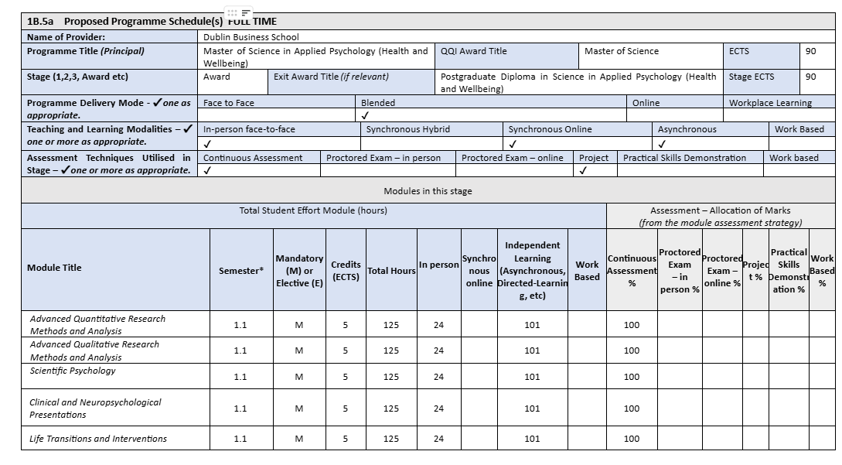
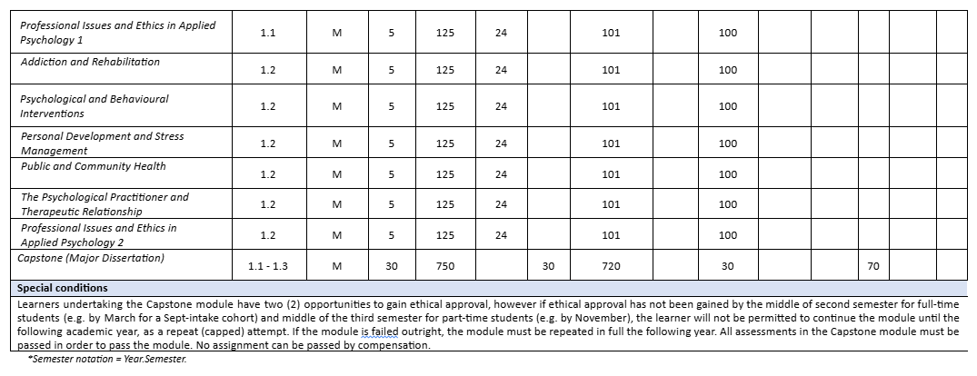
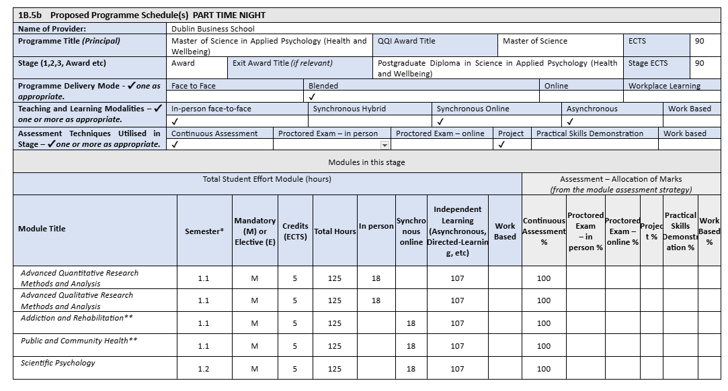
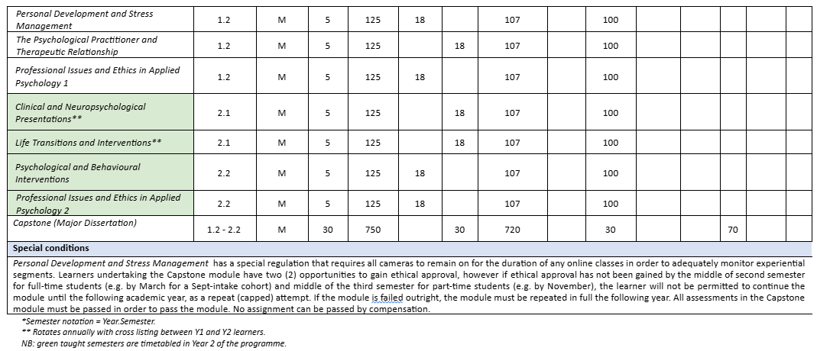
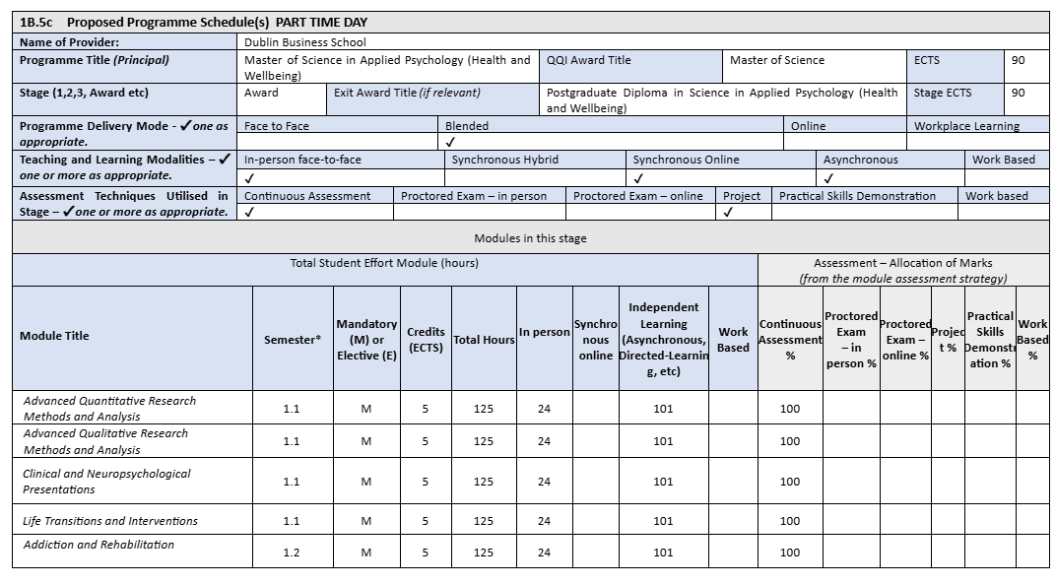
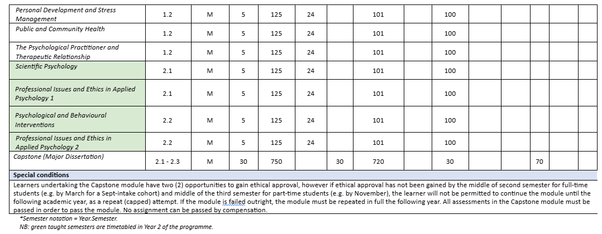
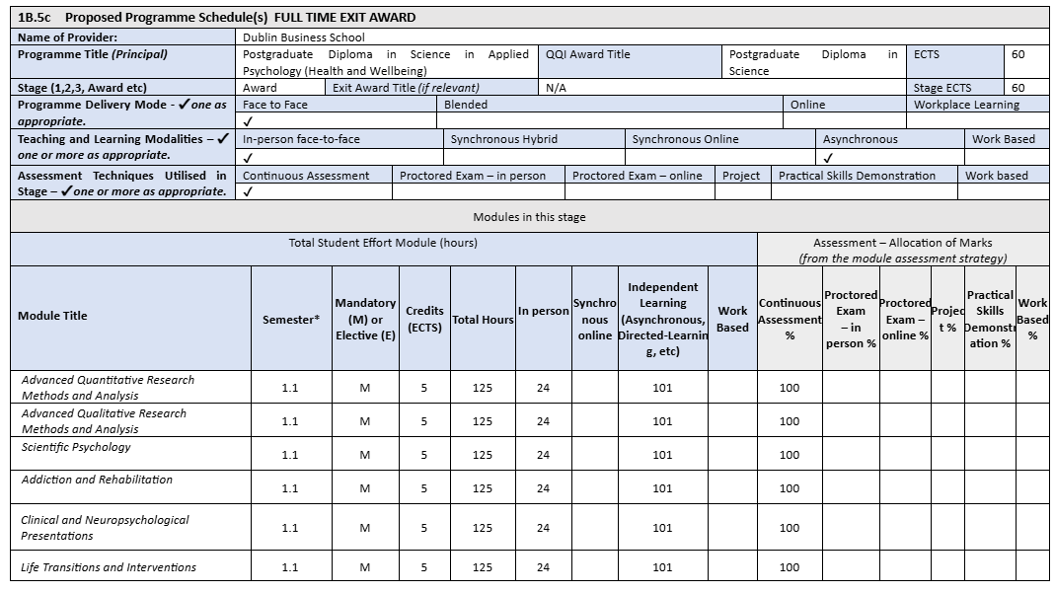
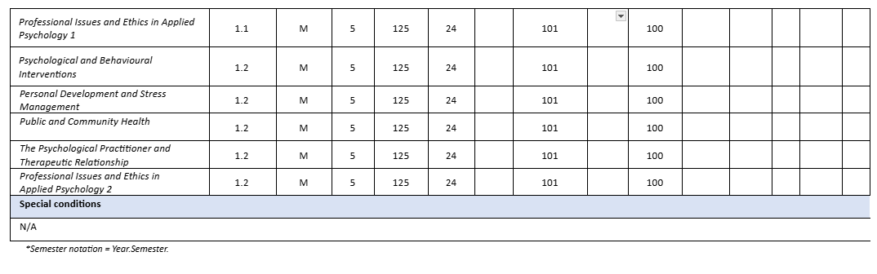
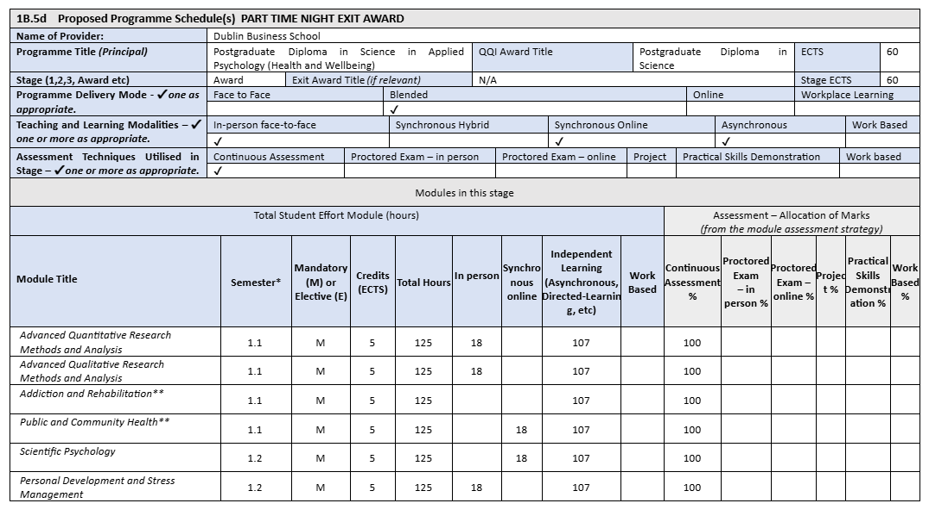
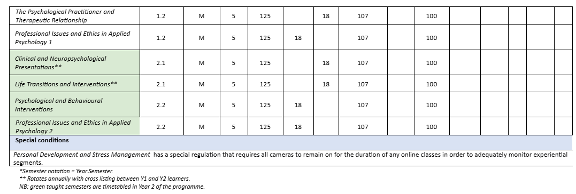
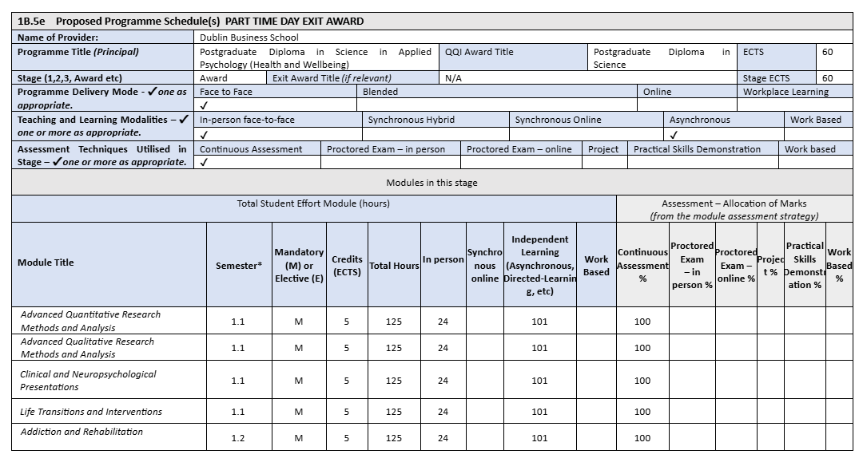
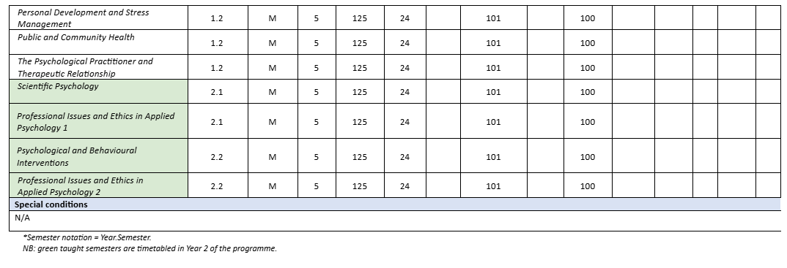

Replace throughout with actual programme title.
Replace throughout with actual programme title. Copy and paste this table for any additional embedded programmes.
http://www.coe.int/t/dg4/linguistic/Source/Framework_EN.pdf (accessed 26/09/2015)

